GEORGIA O'KEEFFE - ABSTRACT WARM/COOL COLOR FLOWERS
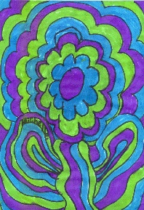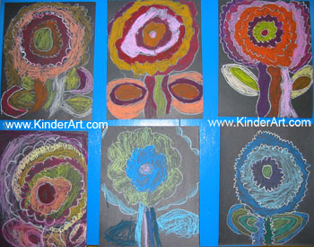
Summary:
Students will learn about warm and cool colors. They will then create vibrant abstract flowers using markers, pastels or paint. There is also an opportunity to study Georgia O'Keeffe.
Objectives:
Students Will:
- Create a drawing of a flower using Georgia O'Keeffe as their inspiration.
- Develop skills in drawing and composition.
- Understand the difference between realistic and abstract.
- Know the warm colors (red, yellow, orange).
- Know the cool colors (blue, green, violet).
Vocabulary:
abstract, enlarge, warm colors, cool colors
What You Need:
- 9" x 12" white drawing paper
- permanent black markers
- watercolor markers
- Optional: oil pastels can be used instead of markers.
What You Do:
- The students will view and discuss Georgia O'Keeffe's flower paintings.
- Teacher will demonstrate drawing the flower on white paper using a permanent black marker (or oil pastels). After the demonstration, students will try their hand at drawing their own flowers. They should create a warm color flower - and a cool color flower.
- Draw a circle about 1/3 of the way down on the paper.
- Draw a 3 scalloped circles around the original circle.
- Draw 4 wavy lines for the stem. Make sure that they touch the flower top and the bottom of the paper.
- Draw a small leaf on each side of the stem. Follow the shape of the leaf, draw several larger outlines of the leaf.
- Repeat the scalloped lines for the flower top until the entire paper has been filled with lines. It will appear that the flower extends beyond the paper.
- Repeat the lines for the leaf until the entire bottom of the paper has been filled in with lines.
About Georgia O'Keeffe:
Georgia O'Keeffe (1887-1986)
American abstract painter born in Wisconsin. She attended the Art Institute of Chicago, the Art Student's League in New York, and Colombia Teacher's College in New York. She was an art teacher before she became a full time artist. She was a leader in the development of the American Modernism Movement. O'Keeffe painted still lifes, massive flowers, the New York at Night series, southwestern landscapes and stark bones found in the desert. In 1939, she was selected as one of the twelve most outstanding women of the past fifty years by the New York World's Fair Committee. Her painting, Sunset-Long Island, was chosen to represent New York in an exhibition of the art of the United States at the World's Fair. In 1985, O'Keeffe was granted the Medal of Arts by President Ronald Reagan.

